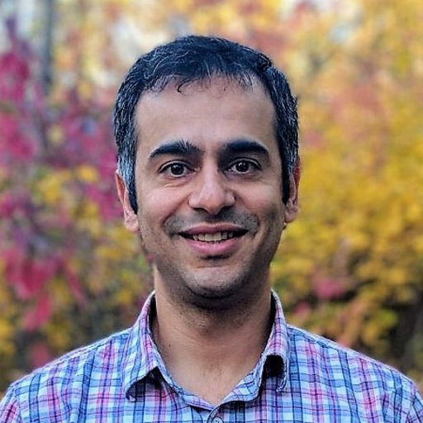 |  | SCHOOL OF nutritional sciences and dietetics: research deputy  monthly talk  Lecture on:  Applications of Metabolomics to Precision Nutrition  By:  Dr. Ammar Hassanzadeh Keshteli  Monday 17th Jan.  (27th Dey)  Tehran 10:30 AM

Dr. Ammar Hassanzadeh Keshteli

Postdoctoral Fellow, Department of Biological Sciences, University of Alberta, Canada

https://www.skyroom.online/ch/virtualtums/nsd-webinars

